RIVA 1920
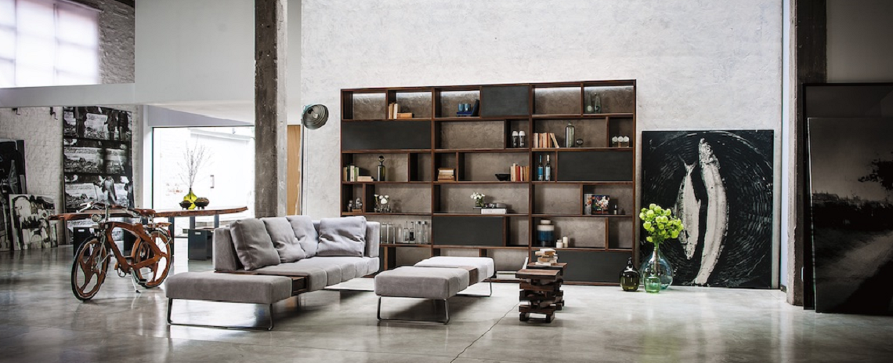
Build furniture ready to challenge time by respecting the environment.
For 95 years the above is the thinking leading and justifying any daily action or decision by
outlining a production reality made of tradition, culture, creativity and innovation. The love for
the nature and the search for a high quality life standard beat the time of the company where
craftsmanship is combined with technology, where design enhances the ideas and where the
attention and care for each detail give birth to something special, unique, timeless.

Riva 1920’s KEY POINTS
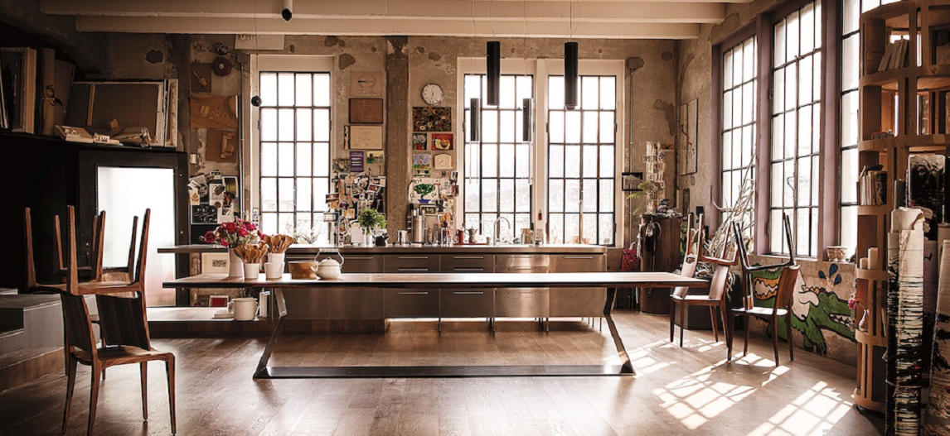

Remembrance of what has been. Witness of what is. Precursor of what will be
We keep and hand down the craft traditions of whom has preceded us
We produce quality furniture in real natural wood
The hands of our carpenters are our best tools
We help nature to take shape
We express our craftsmanship through the care of details
Total flexibility and tailor-made solutions for our customers
Innovation and technology at the service of design
We respect the environment during the whole production cycle
Guarantee of a product totally made in Italy

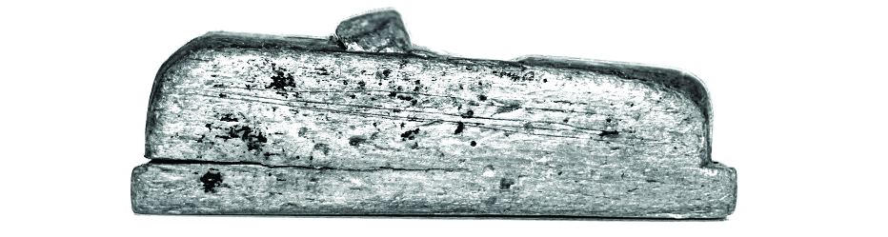
Riva 1920’s history

It all starts in 1920 in Vighizzolo, Cantù, in the heart of the Brianza area of Lombardy, in a small family-run artisan workshop founded by Nino Romano, specializing in the production of classically styled solid wood furniture.
Shortly after the end of the war, in the 1950’s, Mario Riva joins the workshop, which continues their father’s activity and employs a handful of workers. They continue to produce models in classical style, always prioritizing the question of quality in line with the traditions of the typical cabinet making skills of the area, the traditional cradle of high quality Italian furniture production.
In 1970 the brothers Maurizio and Davide Riva follow in the footsteps of their father and grandfather, starting as woodworkers in the workshop below their home, focusing on made to measure furniture and expanding to 1,600 private customers. A long period of commitment and valorization of the use of natural wood and craft skills starts, aspect that later becomes the main feature of Riva1920 and in 1987 the new headquarter is opened in via Milano, Cantù, employing about 30 workers. In the same year, the sister Anna enters the family company, becoming the head of the administrative office. Following a visit to New York by Maurizio Riva durig the 90’s, the next years see a fundamental change with the company adopting the North American custom of using reforestation timber and, with this, there begins the production of solid cherry wood furniture inspired by their models devised by the Amish and Shaker religious communities in America. Gradually a precise design identity begins to evolve, defining itself commitment to quality and naturalness with the use of completely natural glues, waxes and oils.
In 1992, Riva 1920 presents its collection for the first time at the Milan International Salone del Mobile and starts to make a name for itself both in Italy and abroad. At the same time production process was subject to an inevitable advance in industrialization and technological innovation.
During the following 10 years, the Riva family entrepreneurial intuitions promoted the importance of collaborating with designers of international renown, something which went hand in glove with Riva 1920’s move towards sustainable design. In the meantime, with the entry into the firm of the fourth generation, Monica, Stefano, Elena, Marika and Andrea, new markets and new horizons have been introduced to the company philosophy of uniting functionality and aesthetics without ever forgetting the importance of leading a healthy and sustainable life. Alongside American reforestation timber, the company has introduced recycled wood like ancient New Zealand Kauri, the marker posts from the Venetian lagoon, and the Lebanese cedar, to remind the world that wood is a renewable but not infinite resource.
Sustainability, design, research, social awareness and cultural promotion became a fundamental part of Riva 1920’s activity.
In 2005 the second production unit in Cantù (Via Genova) opens and 2010 sees the completion of the construction of the new Riva Center, that houses on the ground floor a Showroom of about 1200 sq. m. The first floor is taken up by the Wood Museum with its collection of over 4,000 pieces of woodworking machines and tools. This captivating building is completely covered in larch wood, symbolizing the essential unity of solid wood products.
Today the firm can boast a working relationship with over 100 designers who try to give tangible “form” to the wonderful material that wood is and, with that aim in mind, a third production unit for technologically advanced processes was opened in 2013. “To produce with honesty in order to hand down our furniture to future generations, constructing articles that defy time and fully respect our surroundings”, this has been the idea that has guided and motivated all Riva 1920’s day to day actions and decisions for the past 95 years, always faithful to its principles. It is an idea that has defined the company as a producer, built on a foundation of traditions, culture, creativity and innovation. Love of nature and the quest for an enhanced quality of life define the pulse of this company, where craft skills and values combine with cutting-edge technology and where design and attention to detail unite to create something truly special, unique and timeless.

OUR WOOD
The products that make up the Riva 1920 collection are made of genuine solid wood of reforestation, using varieties such as maple, cherry, oak and walnut. Characteristic feature of the company is the wood of reuse, such as the thousand-year old Kauri from New Zealand, Briccole of Venice and the scented cedar from Lebanon.

REFORESTATION WOOD
Each single piece of furniture is exclusively made with wood coming from controlled
reforestation areas, a daily commitment towards nature and the environment around us, a
precious and an inestimable patrimony we want to preserve and safeguard.

KAURI · THE LORD OF THE FOREST
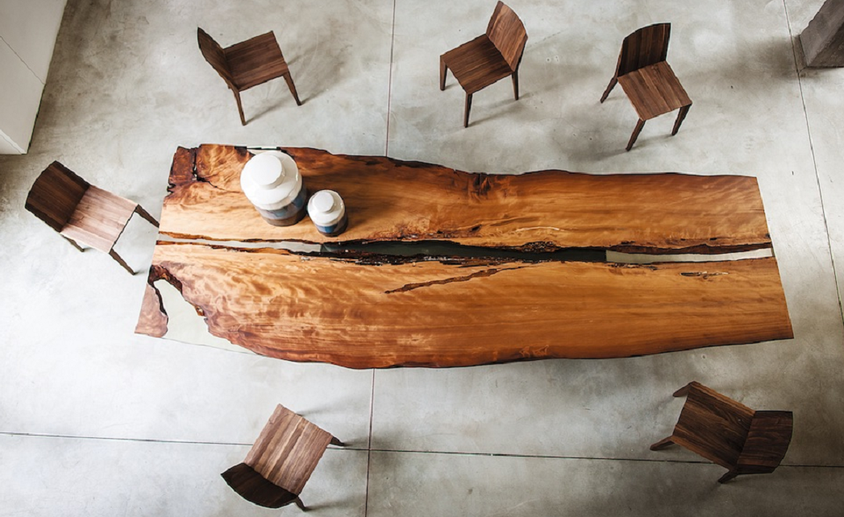

Tane Mahuta in Maori means Millennial Kauri, which is the native biggest and most famous
tree of New Zealand, and also the oldest wood of the world. Grown up in the Jurassic Period
these vegetal giants have been cut down by enormous natural disasters more than 50.000
years ago thus remained buried under meters of mud and unchanged until our days. Logs up
to 70 meters of length and 9 meters of diameter are brought to light again, which are true
natural sculptures ready to be transformed into unique design pieces.

BRICCOLE
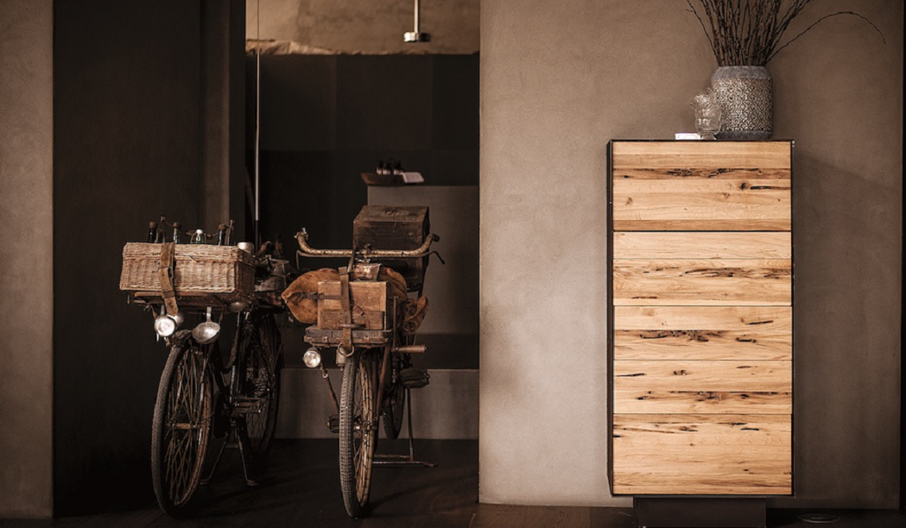

The Riva1920 intuition of giving a new life to these oak posts was born from the great attention
towards the environment and the ecology. The Briccole are the unquestioned main characters
of Venice, which lead the boats and mark the Lagoon low tide and are periodically replaced
due to wear. Made unique pieces by the industriousness of shipworms, small molluscs, Briccole
are transformed into exclusive pieces of furniture able to convey a special emotion.

CEDARWOOD
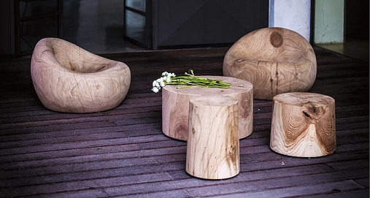

Majestic logs of scented cedarwood, fallen due to natural events or cut down for programmed
schedule, are the start point for the working process of this precious wood which is shaped by
using CNC machineries with 5- and 6-axis. An innovative technology which transforms a raw
log into a design object with a peculiar and unmistakable scent, and afterwards is sanded and
finished by hand.

OUR MATERIALS
Riva 1920 pays great attention on selecting the best materials to be used in their furniture collection, characterized by reliability and long duration. The quality of the raw materials is at the base of the production process and starts with the choice of the most prestigious wood together with wood coming from controlled reforestation areas.
The research for quality of the materials can be found in the whole production chain, from the metal bases to the ironmongery, to leathers and textiles, which are available in a wide selection of colors.
Every element undergoes detailed tests to verify quality and functionality and uses vinyl glues and are finished with oil and natural wax, the guarantee of a 100% natural product.

PHILOSOPHY
Our products come from working techniques of the wood tradition, thanks to our wise artisans and to the use of advanced technologies. This allows the realization of products of great quality, which have their own distinctive characteristics and which can be easily adjustable to custom-made products.
The final product undergoes a functional test and an analysis of the aesthetic conformity, in order to respect the original design.

MUSEUM OF WOOD

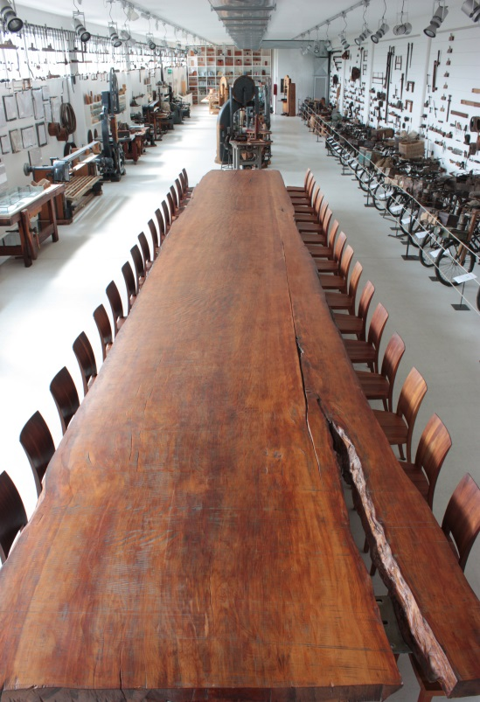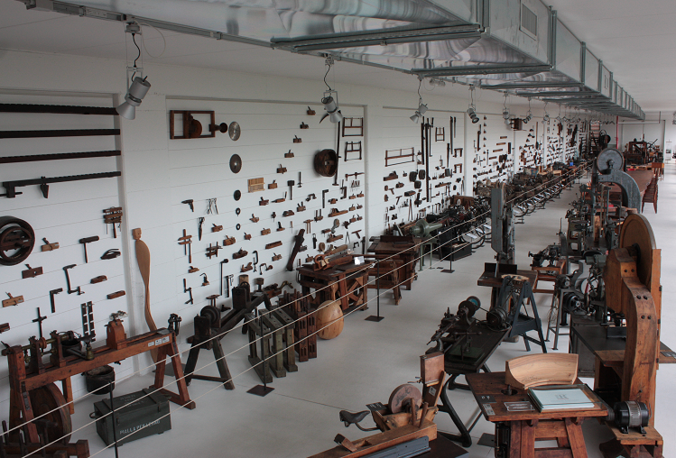

The structure of the centre is almost entirely covered with larch-wood, one of the most long lasting and weather-resistant woods. The interior has been designed to bring out the essence and integrity of the furniture made of solid wood. The models on show are offered as clear examples of the different types of wood available and the variety of the company’s output which is updated every year to keep abreast of trends. The top floor houses the Museum of Wood, which gathers over 4.000 historic woodworking machines and tools. This is the biggest of such collections in the whole of Italy. The aim of the exhibition is to rediscover the origins and traditions of the woodworking industry in the Cantù area.
Riva 1920 collection is freely open to the public and to all those interested in learning about the traditions of woodworking.

SHOWROOM

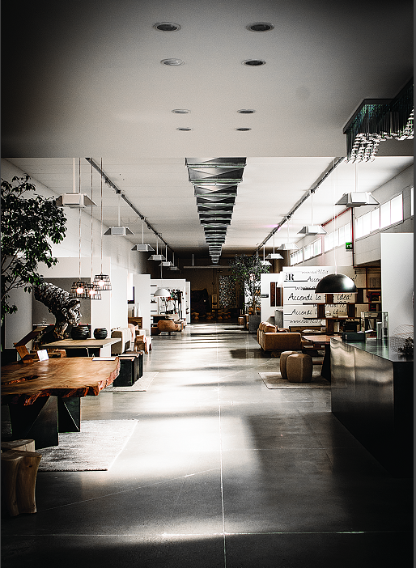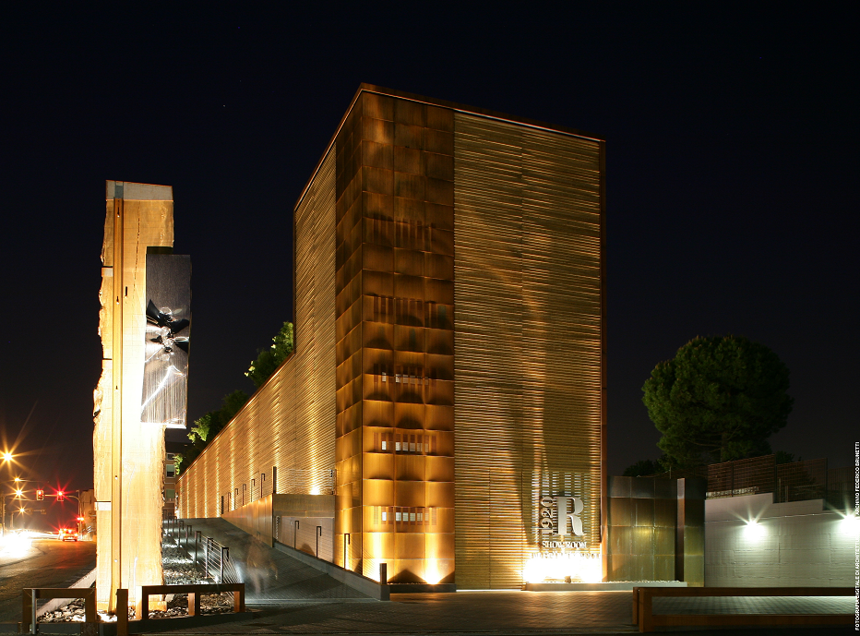

The ground floor of the building hosts the Showroom, aimed at gathering the company’s latest creations, the projects proposed for realization in the near future and aimed at welcoming customers who are there able to see and touch the renowned Riva 1920’s quality. This space, as large as 1.200 square metres, is the perfect niche to enhance the finishing touches of Riva 1920’s products. The area also gathers special projects that have been milestones in the company’s history.
There is the Briccole di Venezia project for which 34 internationally renowned designers designed works of art that re-used the posts that aid navigation in the Venetian lagoon.
The works in Lebanese cedar wood, modelled by technologically advanced machines and detailed by the knowledgeable hands of craftsmen, take on a variety of forms depending on the creativity of the architects who are often very attracted by the peculiar character of this wood.
And finally works in Kauri, an ancient wood from New Zealand, whose age varies between 5,000 and 40,000 years and whose large dimensions allow us to carve out of a single trunk tables up to 12 metres long.

