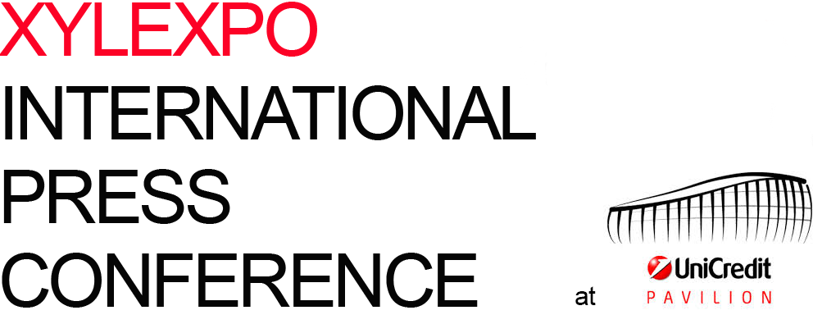

12.02.2016

03. SPEECH BY LORENZO PRIMULTINI
president, Acimall
“An overview of Xylexpo 2016”

It‘s a great pleasure to meet you today, because we need your support this year more than ever: there are many ideas and projects we are working on. It is essential to be supported by opinion leaders and trade media from all over the world, to help us inform Italian and international operators about what we are going to do. Not only for the 2016 event, which is coming up soon, but in the short and medium term.

The world, our industry, has been going through changes you know better than me.
No one can stand at the window and look, waiting to take a direction until the situation gets stabilized, because in the context we are operating in, only one thing is for sure, i.e. constant change.
At the next Xylexpo – the biennial international of technology and supplies for the wood and furniture industry, to be held at Fieramilano-Rho from May 24 to 28 – we will have the opportunity to show this. We will do that with the result of our work as organizers, and exhibitors will also play their part, as the real protagonists of the event.

I believe, we believe that this exhibition will feature plenty of innovation: looking around, everyone will realize how and to what extent wood technology has changed.

WELCOME TO GUESTS
Let me take a break from this overview and welcome the guests who have joined us today.
You have already listened to Ferdinando Pastore from Ice and Corrado Peraboni from FieraMilano, and I thank them both for their time and words.
With Ice and FieraMilano, we have been walking together for a long time, we carry out several projects and initiatives to the benefit of our industry and its actors. Each decision we make in the future will result from our collaboration and friendship with them, from their tangible support.
With them, thanks to them, we are implementing a number of promotion activities, in Italy and around the world, so I want to say thank you for your attention to our industry.
Today, “teaming up” is the key to any system: without new partnerships, without encouraging solid relationships, it is hard to add value to our experiences.

First of all, I want to state that Xylexpo is the only Italian event dedicated to technology and supplies for the wood and furniture industry sponsored by Eumabois, the Italian Ministry of production activities and Cfi-Industry Trade Fairs Committee (Confindustria), with the proactive and real cooperation of Ice-Italian Foreign Trade Agency and Fiera Milano.

And it is not mere chance that, today for the first time, FederlegnoArredo is attending one of our events.
We have been joined by Giovanni De Ponti, who has been able - together with his staff - to guide and manage a period of big changes for the federation and the Milan Furniture Show, in his position of general manager.
We have always believed that tighter integration across the supply chain, closer relationships with the representatives of the excellent and variegated users of our technology, will generate an endless virtuous circle.
Mr. De Ponti is here with us to give a tangible sign that the time has come, so let me express my gratitude and excitement for what we can and shall do together.

Now a due recognition of our “testimonial”, if he allows me this definition. As you might remember, at the press conference for the 2014 edition we hosted Paolo Fantoni, a successful entrepreneur.
This year we have Maurizio Riva, who more than many others has been able to combine technology, creativity and design into a new language, while also finding a meeting point between machinery and handicraft skills, understanding that manual labor and respect for raw material wood are values that should be added to technology, they cannot be canceled or substituted.
He is a man who not only believes in what he does, but also has strong values and principles that urge him to look at the territory, his colleagues, the furniture region Brianza searching for new directions and examples like Riva1920.

XIE-XYLEXPO INFORMATION EVENT
A big thank you also goes to the companies you see in this room.
This year, for the second time, we are hosting a few “top exhibitors” of Xylexpo, companies that really believe in teamwork and have decided to be sponsors of this day and to leverage the opportunity to meet you for a preview of the new products they will display next May.
To all of them – Salvador, Emc, Giardina Group, Cefla Group, Scm Group, Homag Italia, Biesse Group, Greda, Incomac, Leuco, Costa Levigatrici, Metal World, Imal, Pal – a big thank you; and to all of you, an invitation - needless to say - to dedicate the time and attention they deserve.

XYLEXPO GROWING
We are looking forward to a successful event, as I have explained several times in recent months.
The economic scenario, as Acimall’s director Dario Corbetta is going to explain later, is definitely more positive: 2015 closed with improving figures for the Italian manufacturers of technology for wood and wood-based materials, and looking at Xylexpo, everything indicates that we will exceed 2014 results, when we had 440 exhibitors, including 119 foreign companies, over a total surface of 26,176 net square meters.
To date, figures are much better than in the same period of two years ago, with just above 300 exhibitors, one-third from abroad, who have submitted registrations for a total exhibition area of approximately 25 thousand meters, very close to the 26,176 square meter result of 2014. So, we expect to get very close to the 450 exhibitors and 30 thousand square meters thresholds.
We are optimistic also for visitors: we expect better results than in 2014, when we had 44 thousand visitors in five days, or 15,250 “unique visitors” (30 percent from abroad), a figure we offer to our audience to evaluate the real business opportunities that Xyexpo can offer.

And here comes the first news: as usual, entrance to Xylexpo will be free for all operators who register online at www.xylexpo.com; However, without a pre-registration, an entrance fee will be applied starting from this edition: 15 euro for one day, 25 euro for the entire period. We decided to introduce an entrance fee (though lower than other industry exhibitions), because our priority is to discourage curious people and to do all we can to have motivated visitors. As we said in the previous editions, we do not want to chase numbers, we want to provide a service to exhibitors and visitors, especially in a period when exhibitions must absolutely change.

This year, again, the layout will be divided into three halls: in halls 1 and 3 machinery, tools and accessories for the furniture industry, for secondary operations and panel processing. In hall 2 machinery and equipment for solid wood and all sectors related to primary operation, construction technology and wood-based semifinished materials, with an open area extension for forestry exhibitors.

COMPREHENSIVE OFFER, SHARED PROJECT
As I said, there are many reasons to be optimistic.
Someone might remember my speech of two years ago, at the National Museum of Science and Technology, when I said that I believed our joint efforts and shared goals were “another big step towards total reunification that will allow us to say– in 2016 – that the entire Italian industry is back to its reference platform”.
And that’s it: today, at last, at Xylexpo we can find all the industry actors, really all of them. As announced a few weeks ago, also Scm Group has decided to come back to Xylexpo, a decision that encourages us to do better and better. This is not just a verbal declaration of intent: as I said at the beginning, this industry has changed deeply and - all together - we can now work to take new directions, to search for different opportunities.
Big groups and small-medium enterprises from all industries and product categories are now aware that they have to exhibit in Milan, because this location is back to its ancient splendor, a place where no one gets satisfied with the results achieved, but keeps looking ahead. To do this, I repeat, we have to work together on a shared project and a big vision.

ACIMALL AT SALONE DEL MOBILE.MILANO
We are attending Salone del Mobile.Milano. This is also great news. The message we want to send out by bringing the Italian wood technology industry to this big event is clear. It’s a strong “debut”, an experience that highlights the close relationship between machinery and design, the bridge between idea and finished product.
We will take a place in the big Milan review, with a booth in hall 14, to show the contribution of technology to living quality, as technology makes beauty repeatable through fast, powerful and flexible solutions, capable of turning even the most gorgeous item, the most elegant piece of furniture, into a product affordable to many more consumers.
For this opportunity to be “exhibitors of Salone del mobile.Milano” we have to thank FederlegnoArredo, and we are sure this is just the first tile of a much bigger mosaic.

WHAT IS AWAITING US IN MAY?
First of all, a successful edition of an exhibition with a long tradition.
In May we are celebrating our edition number 25, a major milestone to start over from, an opportunity to look back at the first edition, from 18 to 24 March 1968, and its protagonists. It’s also going to be the fiftieth anniversary of Acimall, the association of Italian woodworking machinery manufacturers, officially established on January 29, 1966.
Two important anniversaries for a story that deserves respect and commitment for the future.
We will tell this story on Wednesday, May 25, at “Xylexpo Night”, a gala evening you are invited to join for the celebration of both anniversaries and the ceremony of Xylexpo Innovation Awards; this year the award will be dedicated only to innovation and assigned by a jury of academic and professional education representatives, who will select the most innovative products in the “Primary operation”, “Secondary operation” and “Finishing” categories.
You will find the award regulation and much more information in the press kit.

I believe I have taken enough advantage of your attention. There are many more initiatives at an advanced stage, as you will see next 24 to 28 May.
We will talk about that soon.

Let me close by saying thank you to be here in Milan today, to have joined us for this ideal journey from the “Leonardo da Vinci” National Museum of Science and Technology – where we celebrated the values of ingenuity and invention, that were the key topics of the 2014 international press conference – to this wonderful UniCredit Pavillion, imagined and designed by a great Italian architect, Michele De Lucchi.
We are surrounded by ingenuity, design, wood and plenty of evidence that this material, through technology, can be turned into something charming, exciting, epic... You will agree that we couldn’t find a better location to talk about Xylexpo 2016.

Our deep, natural link with design will be visible at Salone del Mobile.Milano, but I don’t want to anticipate anything: I will just invite you to come and see, if you are in Milan next April.

Once again, thank you for coming and for your future coverage of our exhibition in the media.

the spoken word applies

