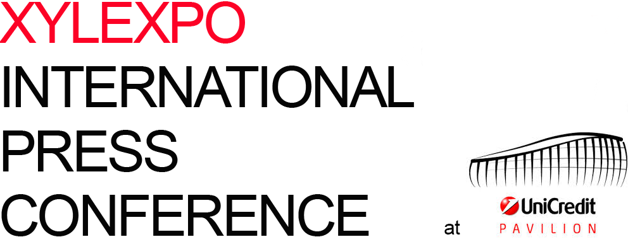

Friday, February 12, 2016
UniCredit Pavilion “Greenhouse” - Piazza Gae Aulenti, 10

THE PRESS CONFERENCE

11.00 a.m. welcome coffee

11.15 a.m. XYLEXPO INTERNATIONAL PRESS CONFERENCE
All speeches in Italian with simultaneous English translation.

Ferdinando Pastore
director, Industrial Technology, Energy and Environment department,
Ice-Italian Foreign Trade Agency
Corrado Peraboni
managing director, FieraMilano
Giovanni De Ponti
managing director, FederlegnoArredo and Salone del Mobile.Milano

Lorenzo Primultini
president, Acimall
“An overview of Xylexpo 2016”
Dario Corbetta
director, Acimall
“The Italian and European industry of technology for the furniture
industry and woodworking”

Maurizio Riva
Riva1920
“Wood, technology, design...”

Q&A

13.00 a.m. “The Italian Taste” lunch buffet and see you in May 2016
14.00 a.m. Free time and departure

During the event: XIE-XYLEXPO INFORMATION EVENT
The “top exhibitors” of Xylexpo 2016 meet the media

For more information:
Luca Rossetti Paola Gandini
phone +39 329 2197752 phone +39 02 89210282
press@xylexpo.com press2@xylexpo.com

