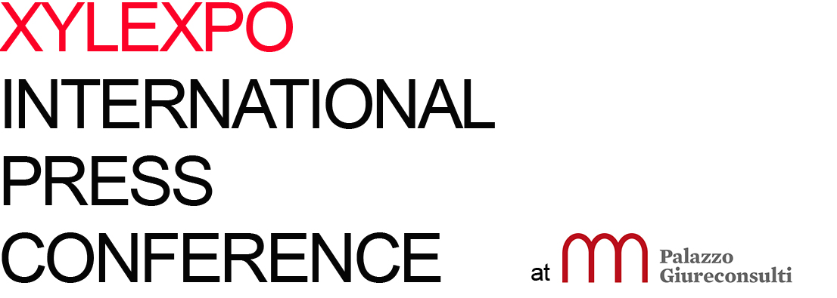

06. XIE-XYLEXPO INFORMATION EVENT 2018:
PARTICIPATING COMPANIES

01 Leuco Philipp Rieger
02 Salvador Christian Salvador
03 Homag Group Mario Caspani, Roberto Pardini
04 Biesse Group Alessandra Fico, Alessandra Magi
05 Leitz Juergen Koeppel, Annekatrin Teschke
06 Giardina Group Luca Tibè, Stefano Tibè
07 Weinig Klaus Mueller, Andrè Engert
08 Metal World Fanny Paviotti, Sonia Zufferli
09 Scm Group Gian Luca Fariselli, Alessandra Leardini
10 Greda Gianni Radaelli
11 Costa Levigatrici Remo Costa, Giorgio Cataldo

12 Finiture collective desk

Milan, 23rd January 2018

