Assago, July 12, 2022
To Xylexpo 2022 exhibitors

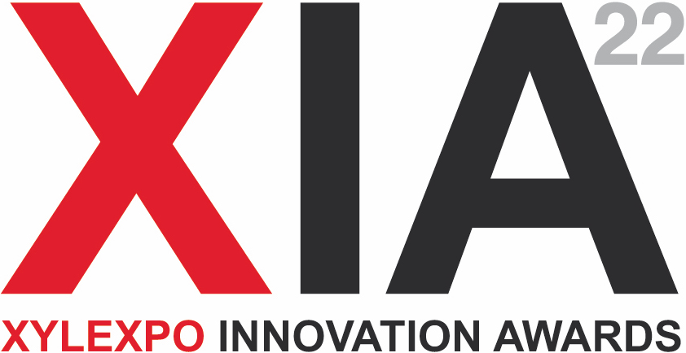

To the kind attention of
SECRETARIAT OF XIA AWARDS 2022
Eng. Matteo Simonetta
Acimall Technical Office
phone +39 02 89210239
tecni@acimall.com

Nomination to XIA Award 2022
By and within September 15, 2022

I, the undersigned, (name and surname) …..………………………………………………………….…….
in my capacity as (company role) ………………………………………………………………….…………
of company (full company name) ……………………………………….…………..………………..………
based in (country, city) ….……………………………………………………………..………………………
in (street, square address) ….…………………………………...…………………… number ……………
ZIP ….…………………………………...…………………… country ………………………………..……..
submit a nomination to XIA 2022 award for the following machine / solution / plant:
model / denomination …………………………………………………………………………….…………

designed to (description of functionality) ……………………………….……………………………….……
…………………………………………………………………………………………….………………………..
………………………………………………………………………………………………………………...…… ……………………………………………………………………………………………………………..….…… …………………………………………………………………………………………………………..…….……
………………………………………………………………………………………………………………...…… ……………………………………………………………………………………………………………..….……

This solution offers the following innovative features:
………………………………………………………………………………………………………………...…… ……………………………………………………………………………………………………………..….…… …………………………………………………………………………………………………………..…….……
………………………………………………………………………………………………………………...…… ……………………………………………………………………………………………………………..….…… …………………………………………………………………………………………………………..…….……
………………………………………………………………………………………………………………...…… ……………………………………………………………………………………………………………..….…… …………………………………………………………………………………………………………..…….……
………………………………………………………………………………………………………………...…… ……………………………………………………………………………………………………………..….…… …………………………………………………………………………………………………………..…….……
………………………………………………………………………………………………………………...…… ……………………………………………………………………………………………………………..….……
The award has been created to recognize innovative solutions presented at Xylexpo, therefore the jury will only consider solutions / activities launched after January 1st, 2020.
The applicant takes full responsibility for the statements contained herein and accepts that, in case of discrepancies and/or non-compliance, the nomination may be canceled and/or the prize withdrawn (if already assigned).
Put an X on the correct option:
Is this solution a “global preview”? YES NO
If NO, is it a new solution for the Italian market? YES NO
If NO, where was it presented for the first time? ……………….……………………………....………
In which year? ……………………....…… Is it currently in production? YES NO

Signature: ……………………………………………………………………………………………………………

Place: ………………………………………………………Date: ………………………………………………

For the purpose of evaluation by the jury, the applicant encloses the following documentation: ………………………………………………………………………………………………………………...…… ……………………………………………………………………………………………………………..….…… …………………………………………………………………………………………………………..…….……
………………………………………………………………………………………………………………...…… ……………………………………………………………………………………………………………..….…… …………………………………………………………………………………………………………..…….……
………………………………………………………………………………………………………………...…… ……………………………………………………………………………………………………………..….…… …………………………………………………………………………………………………………..…….……
………………………………………………………………………………………………………………...…… ……………………………………………………………………………………………………………..….…… …………………………………………………………………………………………………………..…….……

As required by the award call for nominations, the information herein shall be published on the following web site: www.xylexpo.com.

For any information about application procedures, or technical questions, please contact:
Matteo Simonetta
Acimall Technical Office
phone +39 02 89210239
tecni@acimall.com

For logistic and general information about the award organization, please contact:
Luca Rossetti
Xylexpo Press Office
phone +39 02 89210200
press@xylexpo.com

