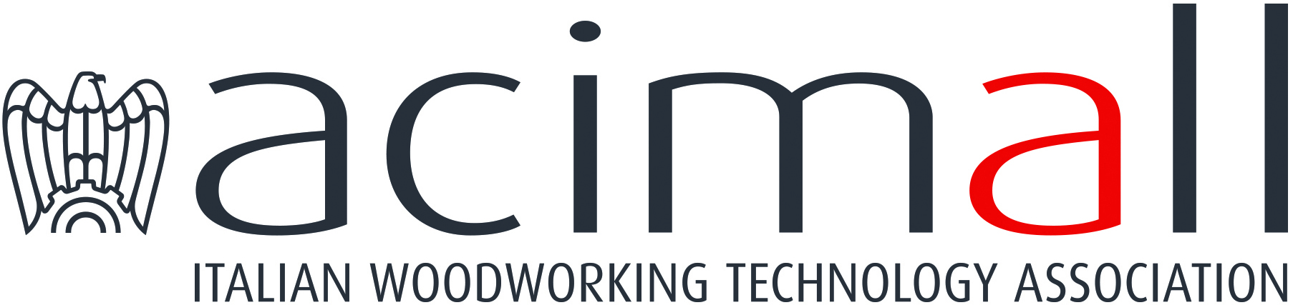 | Acimall  Centro Direzionale Milanofiori  Strada 1 - Palazzo F3  I-20090 Assago (Milano)  phone +39 02 89210200  fax +39 02 8259009  www.acimall.com  info@acimall.com | press office  12 October 2022

TECHNOLOGY FOR WOODWORKING AND THE FURNITURE INDUSTRY

The year 2021 was really positive. This trend was reaffirmed by the Studies Office of Acimall, the association of Italian manufacturers of wood and furniture technology: production amounted to 2,530 million euro, up by 36.9 percent compared to 2020, a year we would like to forget for many reasons, not only economic, and by 11.6 percent versus 2019.
Excellent results also for export, reaching 1,740 million euro (plus 30.8 percent over 2020; plus 10.1 percent over 2019), with a domestic market showing tangible signs of liveliness (790 million euro, up by 52.5 percent over 2020 and 15.1 percent over 2019).
Import also increased in 2021, reaching 244 million euros, 59.4 percent more than in 2020 and 21.4 percent more than in 2019.
As usual, driven by the strong propensity to export of Italian companies, the trade balance was also positive, with a value of 1,496 million euro (plus 27.1 percent over 2020, plus 8.5 percent over 2019). Apparent consumption also increased: 1,034 million euro, up by 54.1 percent over 2020 and 16.5 percent over 2019.

These positive and reassuring figures indicate that the technology industry has overcome the serious difficulties of the pandemic period – unfortunately still fixed in our memories – going back to pre-Covid levels. Such growth has been driven by several measures, incentives and different types of public subsidies introduced by many countries, which caused a concentration of investment decisions that amplified the structural rally of demand.

THE YEAR 2022
The early months of this year were really positive for many international markets, recording double-digit growth of orders and revenues. Such trends supported widespread optimism among market players, reaffirming the trends of the previous twelve months.
However, industry operators and international observers are not underestimating the clouds building up on the horizon, first of all the difficult provisioning of raw materials and components, a “hunger” for supplies that has driven many companies to make important decisions, acquiring suppliers, searching for alternative sources, or simply filling up their stocks.
The impact on price increases, still very lively, was an immediate consequence.
Further critical factors are the enduring sanitary crisis, the closure of some markets for pandemic or war reasons, the devastating impact on energy costs: all these elements have caused analysts to be very cautious in their estimates for 2022. The surveys for the second half of 2022 have revealed contradictory visions, but the overall sentiment indicates that the April-June period will not be remembered as one of the happiest seasons.

The new calendar of Xylexpo in October is a great opportunity to try and draw a balance for this year: "in person" meetings at one of the key events in the international exhibition calendar will certainly give a more reliable picture of 2022 and help industry operators anticipate the end-of-year results.

For more information:

Luca Rossetti

+39 351 9098189 - press@acimall.com

